Domain-Specific Languages (DSLs)

📌 Definition:
# Source: AI Source: Provided by: [Data Path: Persons Table -> ID Column: 1, Name_En Column: Motasem Essam] -> From: [Chatgpt (GPT‑5 Mini)] on [12/9/2025]
Domain-Specific Languages (DSLs) are high-level programming languages designed for a specific task or domain, instead of being general-purpose.

🧠 Simple idea:
# Source: AI Source: Provided by: [Data Path: Persons Table -> ID Column: 1, Name_En Column: Motasem Essam] -> From: [Chatgpt (GPT‑5 Mini)] on [12/9/2025]
DSL = Language made for one specific job

🔍 Key characteristics:
# Source: AI Source: Provided by: [Data Path: Persons Table -> ID Column: 1, Name_En Column: Motasem Essam] -> From: [Chatgpt (GPT‑5 Mini)] on [12/9/2025]
- ✅ Focused on a specific domain (not general use)
- ✅ Easier to use within that domain
- ✅ More expressive for a specific purpose
- ❌ Not suitable for all types of programming

🧩 Examples of DSLs:

🗄️ Query Languages
# Source: AI Source: Provided by: [Data Path: Persons Table -> ID Column: 1, Name_En Column: Motasem Essam] -> From: [Chatgpt (GPT‑5 Mini)] on [12/9/2025]
- Used to retrieve and manage data
- Example: SQL

🏷️ Markup Languages
# Source: AI Source: Provided by: [Data Path: Persons Table -> ID Column: 1, Name_En Column: Motasem Essam] -> From: [Chatgpt (GPT‑5 Mini)] on [12/9/2025]
- Used to structure content
- Examples: HTML, XML

🎨 Style Sheet Languages
# Source: AI Source: Provided by: [Data Path: Persons Table -> ID Column: 1, Name_En Column: Motasem Essam] -> From: [Chatgpt (GPT‑5 Mini)] on [12/9/2025]
- Used to style and design content
- Example: CSS

⚙️ Types of DSLs:
# Source: AI Source: Provided by: [Data Path: Persons Table -> ID Column: 1, Name_En Column: Motasem Essam] -> From: [Chatgpt (GPT‑5 Mini)] on [12/9/2025]
- Internal DSL → built inside a general language (e.g., Python libraries)
- External DSL → standalone language (e.g., SQL, HTML)

🆚 DSL vs General-Purpose Languages
# Source: AI Source: Provided by: [Data Path: Persons Table -> ID Column: 1, Name_En Column: Motasem Essam] -> From: [Chatgpt (GPT‑5 Mini)] on [12/9/2025]
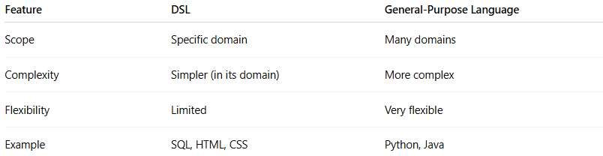
Feature | DSL | General-Purpose (Python, Java)
Purpose | Specific task/domain | Many types of tasks
Complexity | Simple in its domain | More complex but flexible
Flexibility | Limited | Very flexible
Example | SQL, HTML, CSS | Python, Java

🎯 Where DSLs are used:
# Source: AI Source: Provided by: [Data Path: Persons Table -> ID Column: 1, Name_En Column: Motasem Essam] -> From: [Chatgpt (GPT‑5 Mini)] on [12/9/2025]
- 🗄️ Databases (SQL)
- 🌐 Web development (HTML, CSS)
- ⚙️ Configuration (YAML, JSON)
- 🧪 Testing & automation tools

✅ Summary:
# Source: AI Source: Provided by: [Data Path: Persons Table -> ID Column: 1, Name_En Column: Motasem Essam] -> From: [Chatgpt (GPT‑5 Mini)] on [12/9/2025]
DSLs are specialized high-level languages designed to solve problems in a specific area efficiently, rather than general programming tasks.

